BIRLA INSTITUTE OF TECHNOLOGY & SCIENCE, PILANI
Work Integrated Learning Programmes Division
Cluster Programme - M. Tech(DSE)
I Semester , 2022 – 23(January,2023)
Mid semester Examination (Makeup)
Course No : DSECZC418
Course Title : Introduction to Statistical Methods
Nature of Exam. : Open Book (Online)
Number of questions:5
Number of Pages: 2
Weightage : 30 Marks
Duration : 120 minutes
Date : 28th January,2023_FN
Q.1.a).Consider the following summary of a data. [4M]
Write important 4 observations from this summary which helps us to understand the data as a part of pre – processing.
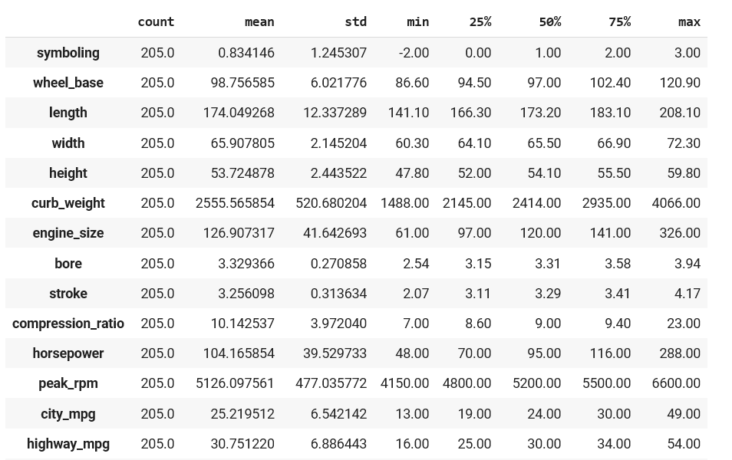
b). Validate the following statement. Justify it. [3M]
“If two events are mutually exclusive, then they are independent also and vice versa”
Q.2.a).If P (A) =1/2, P (B) =1/3, P (A/B) = 1/6 find i). P(B/A) ii). P(B/A’) iii).P(AUB / A) iv).P(B/A)
v). vi). P vii). P [4M]
b).Consider the following information related to road accidents.
Authorities identified that 15% of the road accidents are due to rash driving by self(A), 25%, 20%, 40% of road accidents are due to bad roads(B), road indiscipline by others(C) and various other reasons(D) respectively. Out of these accidents (A, B, C and D) 1%, 2%, 3% and 4% died after treatment. Find the percentage of deaths due to accidents. [3M]
Q.3.a).A random variable X has the density function [3M]
$f\left(x\right)=\{ke^{-0.5 x,}x≥0 0 elsewhere ,$
i).Determine k that renders f(x) as a valid density function.
ii).Find P (-1.5 < X < 2.5)
iii).Find P ([X] =1), where [X] is the greatest integer less than or equal to X
b). Consider the following joint distribution of x and y. [4M]
p(x,y) | x
y |  | 1 | 2
 | 1 | 0.15 | 0.15
 | 2 | 0.20 | 0.20
 | 3 | 0.05 | 0.10
 | 4 | 0.05 | 0.10
- Validate the distribution
- Find Marginal distributions of x,y
- Find P(Y = 2/ X < 2)
- Are they independent random variables?
Q.4.a). If possible, find the probability distribution function of a binomial distribution with mean 4 and variance 4/3. [3M]
b). The life of a certain kind of electronic device has a mean of 250 hours and a standard deviation of 20 hours. Assuming that he distribution of life times which are measured to the nearest hour can be approximated closely with a normal curve, [3M]
(i) Find the probability that any one of these devices will have a lifetime of more than 200 hours.
(ii) What percentage will have life time from 250 to 300 hours.
Q.5. It is observed that waiting time of patients in a hospital is 15 minutes with a Standard deviation of 2 minutes. Sampling is used to validate this observation. Find the probability that the sampling mean lies between 12 to 17 minutes with sample size of 35. [3M]

XXXXXX

